**JFrog Artifactory integrated with Jenkins**

**Step 1 : Intially we need to download the Artifactory packages using below command**

**wget** [**https://jfrog.bintray.com/artifactory/jfrog-artifactory-oss-6.9.6.zip**](https://jfrog.bintray.com/artifactory/jfrog-artifactory-oss-6.9.6.zip)

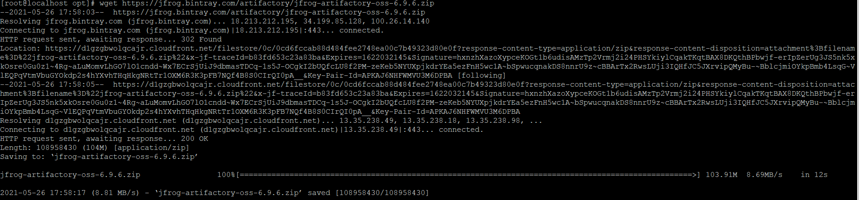

**Step 2:**

**Once download complete . we need to unzip this file using below command**

**unzip jfrog-artifactory-oss-6.9.6.zip**

**Then change the location using cd artifactory-oss-6.9.6. now we are in actifactory-oss-6.9.6. and again change the location to bin directory**

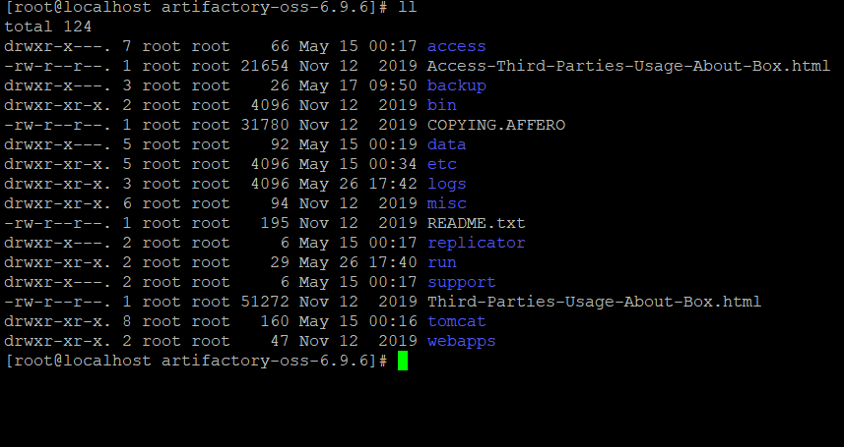

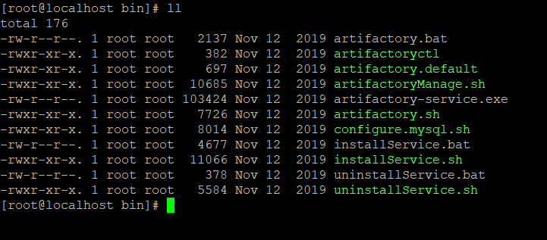

**Step 3:**

**Then need to start the service**

**./artifactory.sh start (service started )**

**Step 4:**

**Finally take the ip address with port 8081**

**<Public IP>:8081 (ex: 192.168.1.25:8081)**

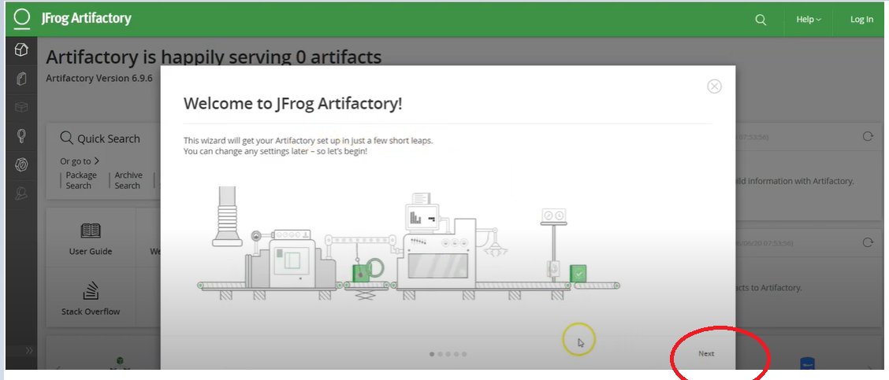

**Click on next**

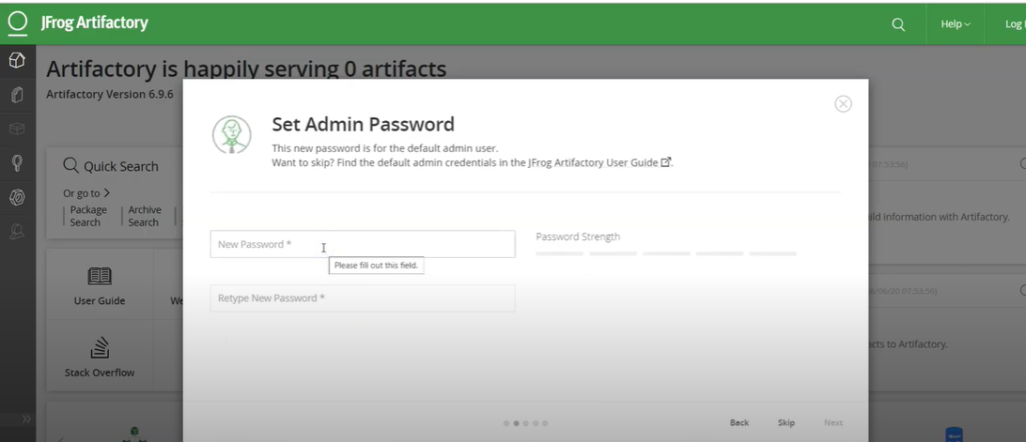

**Here enter the password and click on next**

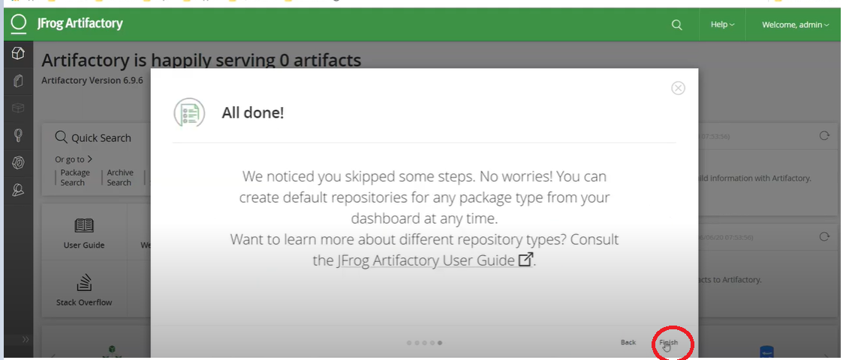

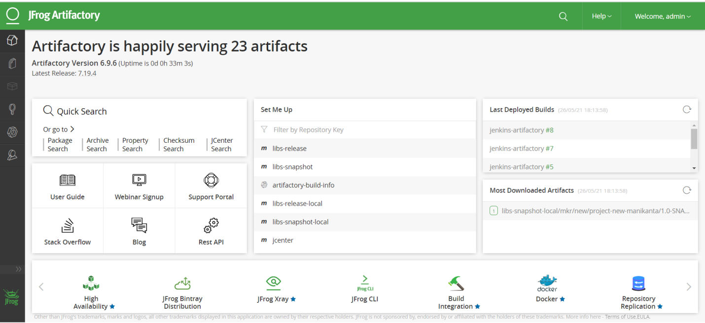

**Now artifactory account was created.**

**And click on Quick setup**

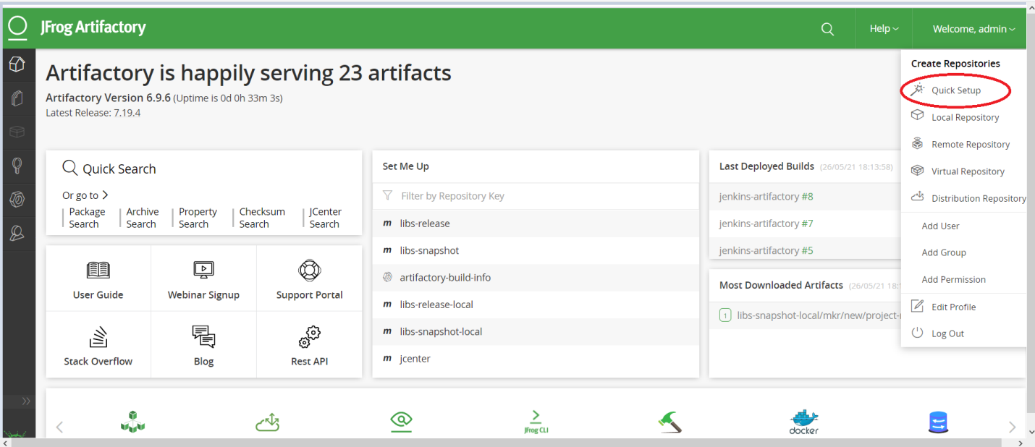

**Then click on maven**

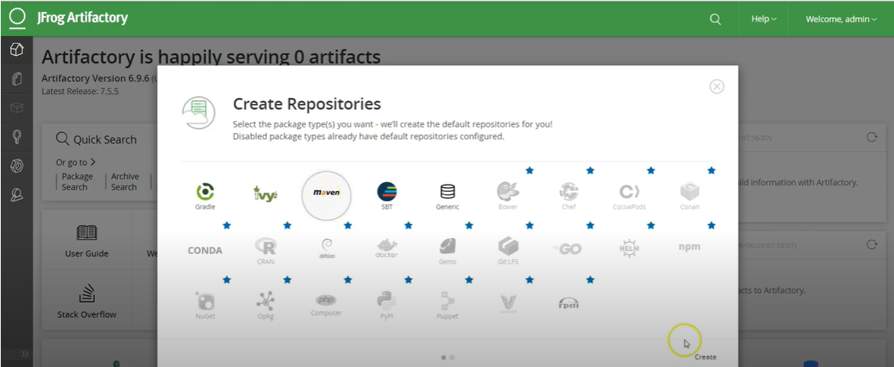

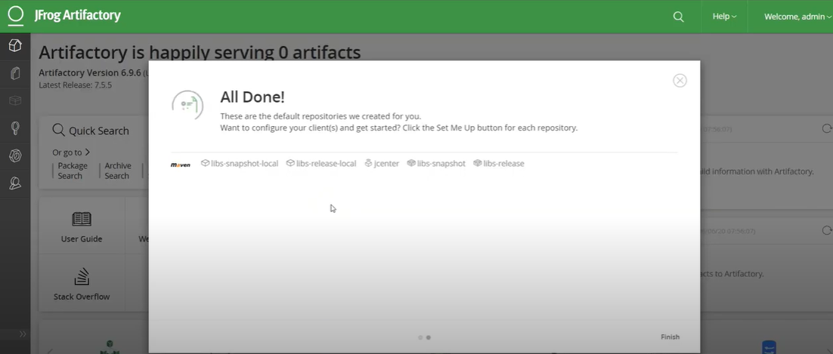

**Click on repository , repositories will be listed .**

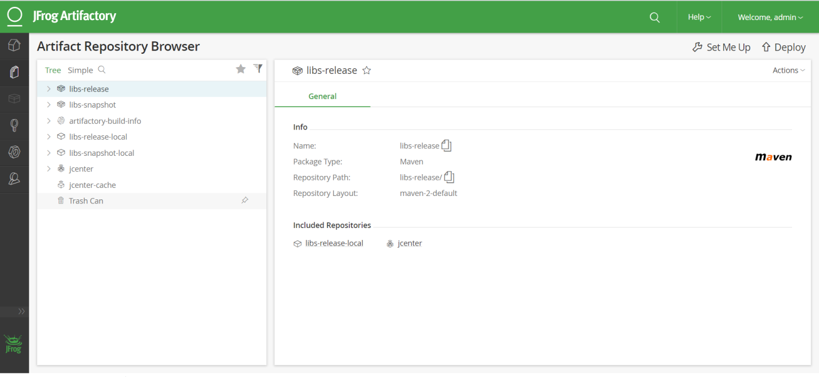

**ARM Integration with Jenkins**

**Login to Jenkins page**

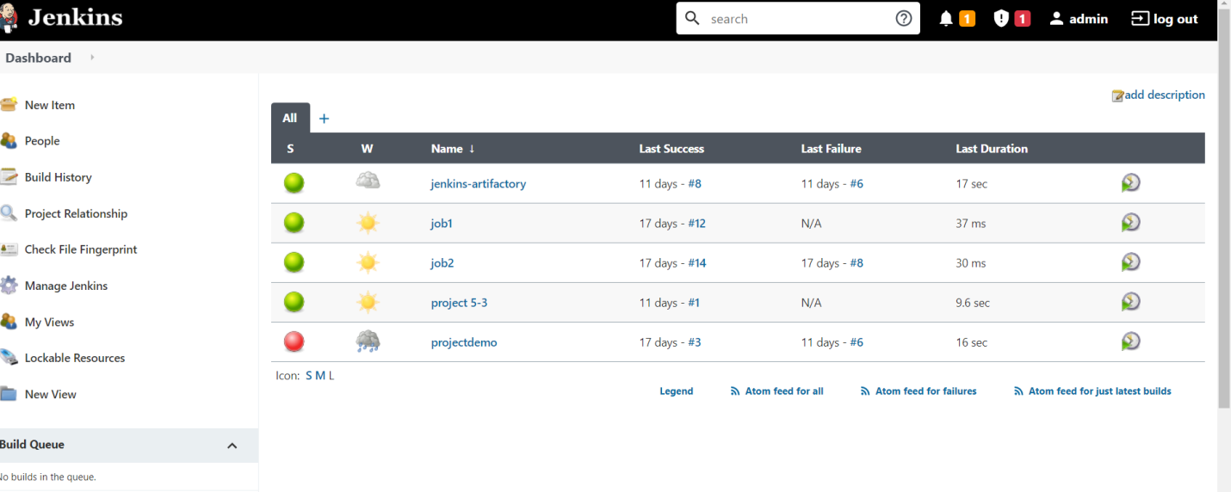

**Goto manage Jenkins and then click on manage plugins**

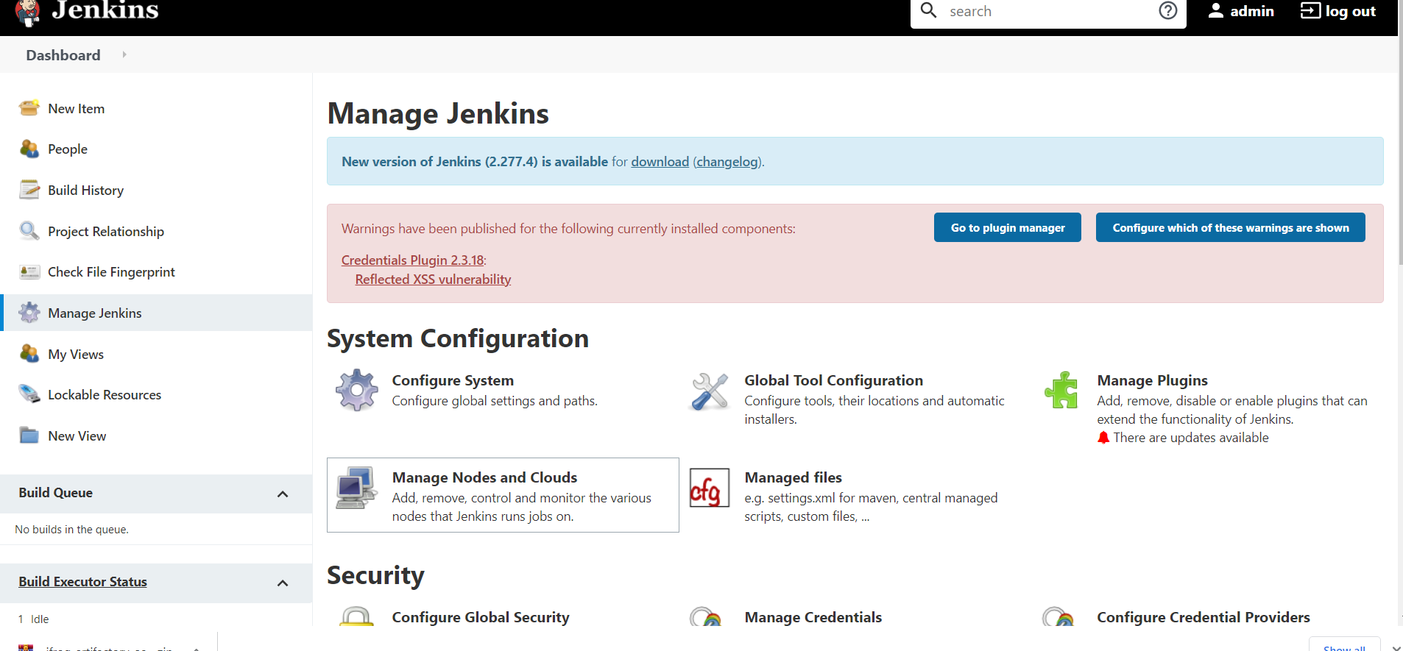

**Then please install artifactory plugin**

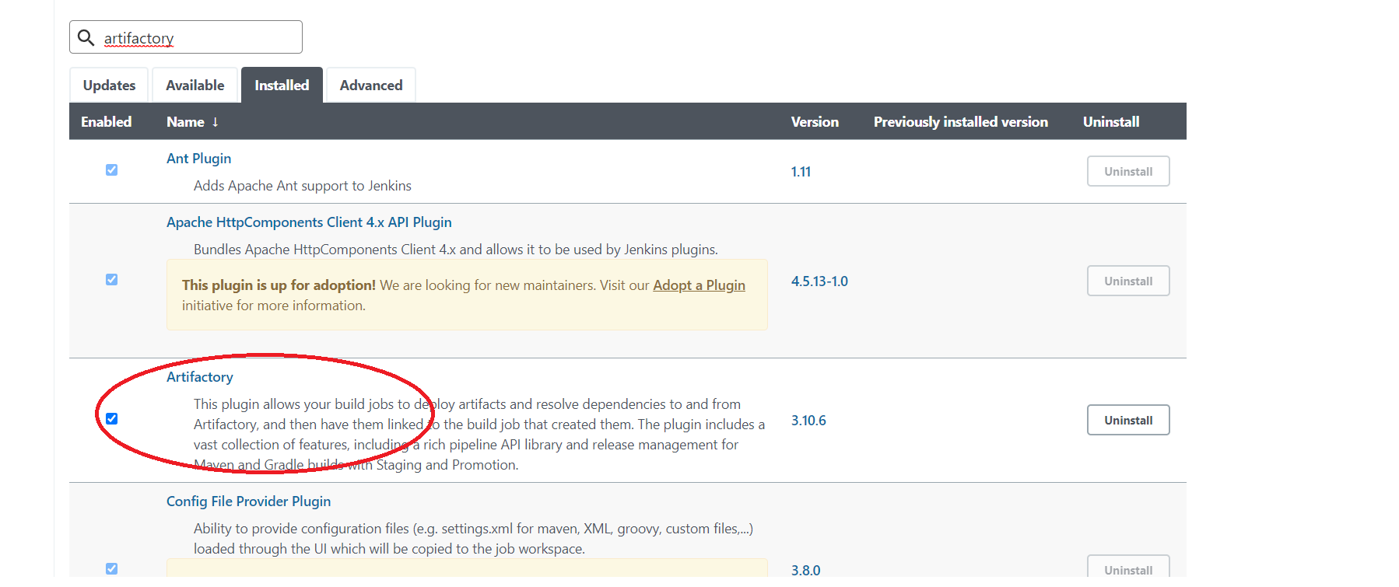

**Next goto manage Jenkins and click on configure systems**

**And give the details**

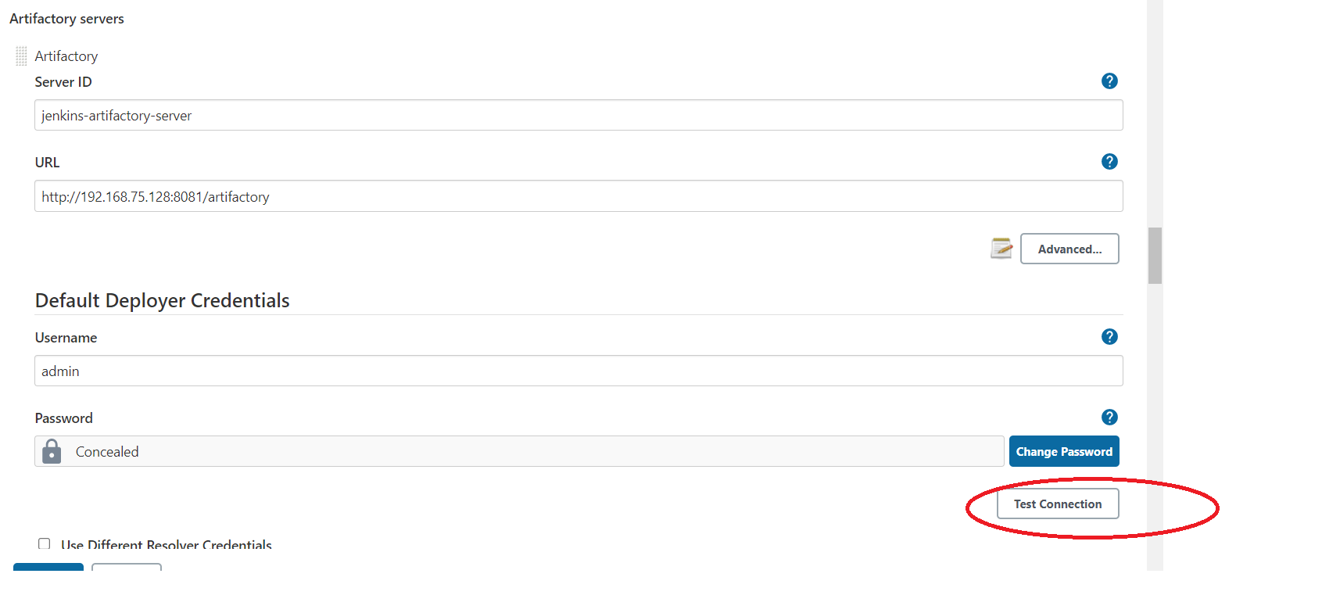

**Once given the details we need to know the Jenkins is communicating with artifactory or not. Just click on test connection.**

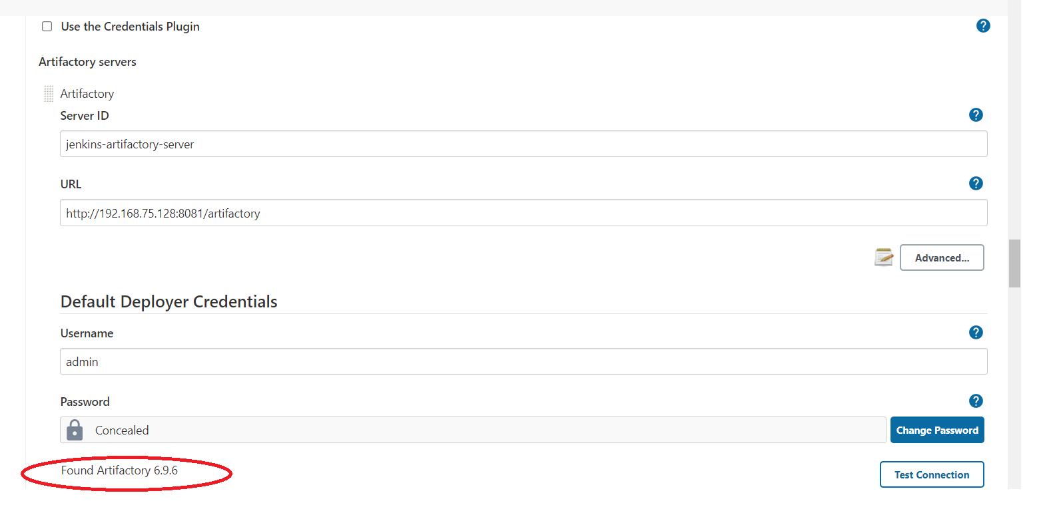

**Once clicked on test connection , if artifactory version is showing its successfully communicated with artifactory.**

**After that we need to create one Freestyle project .**

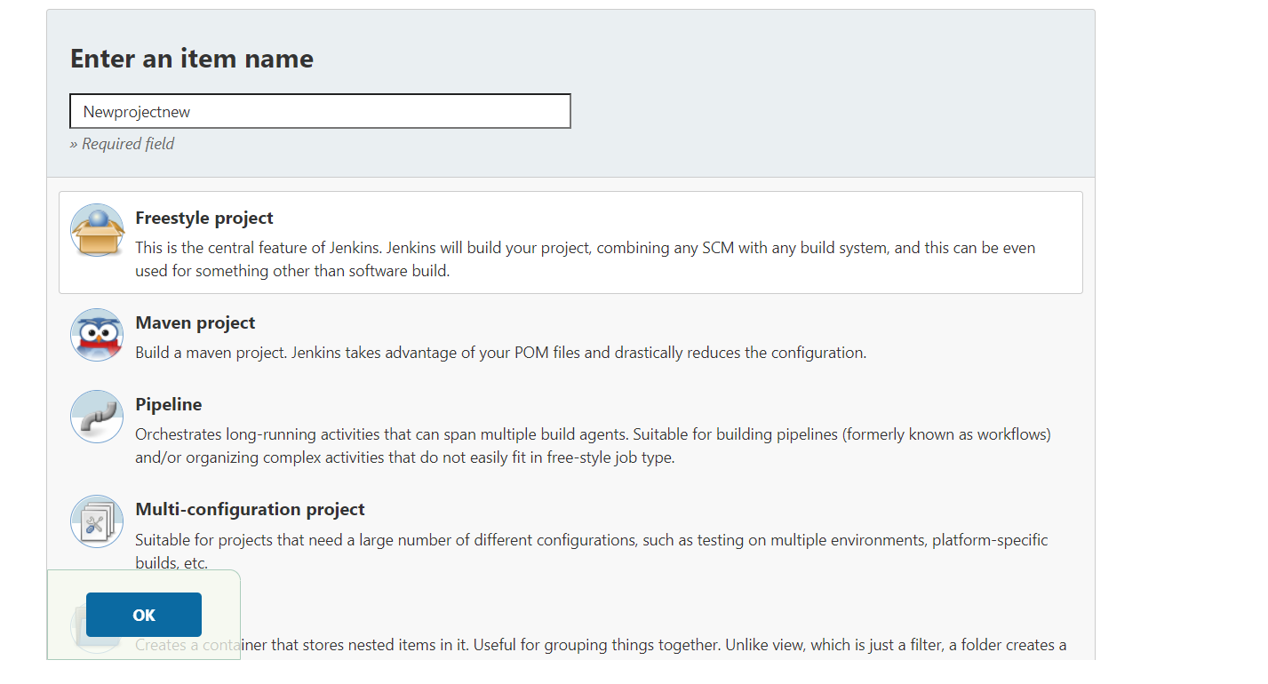

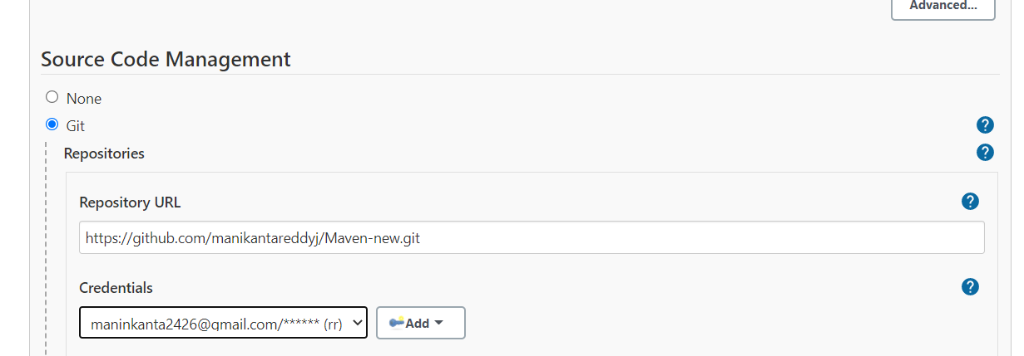

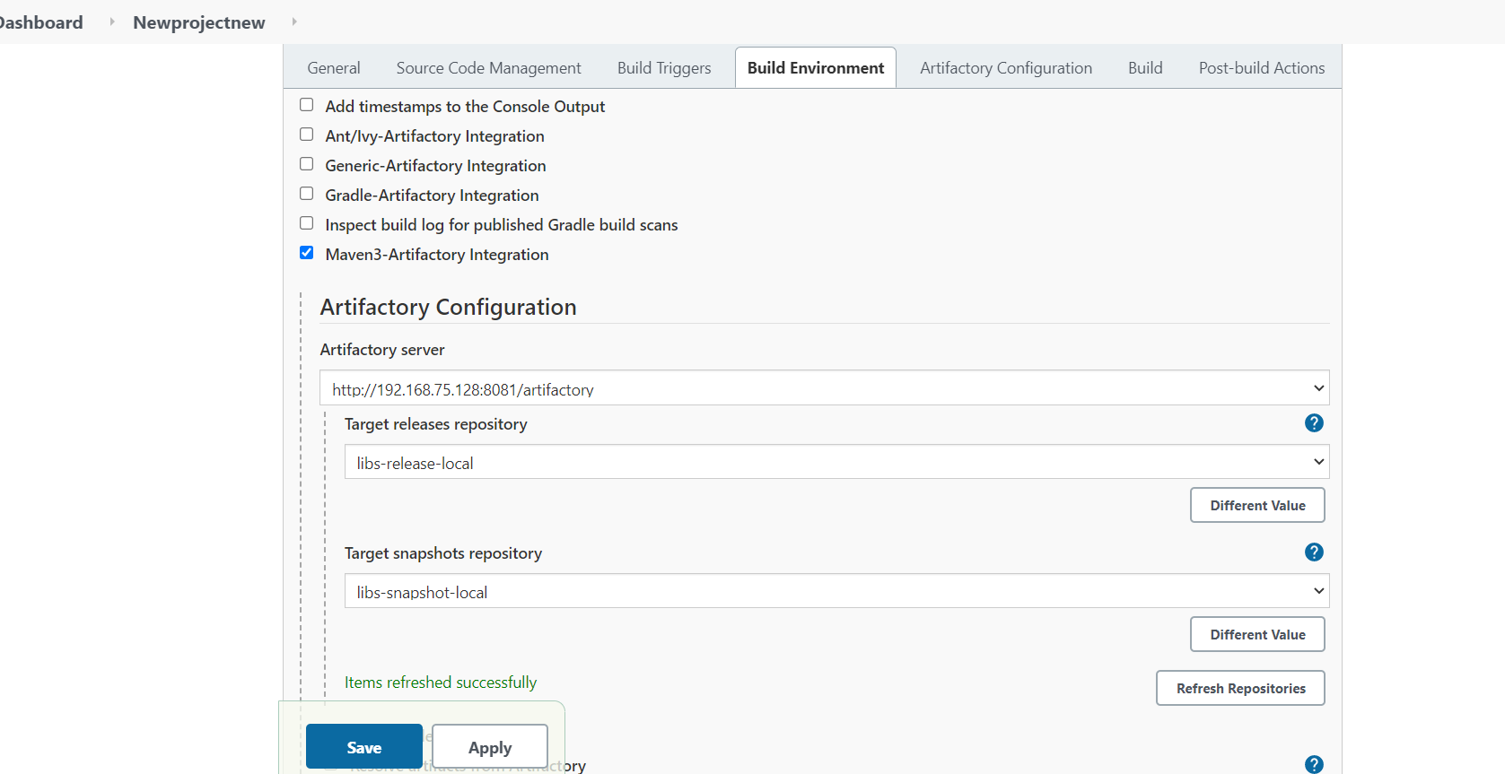

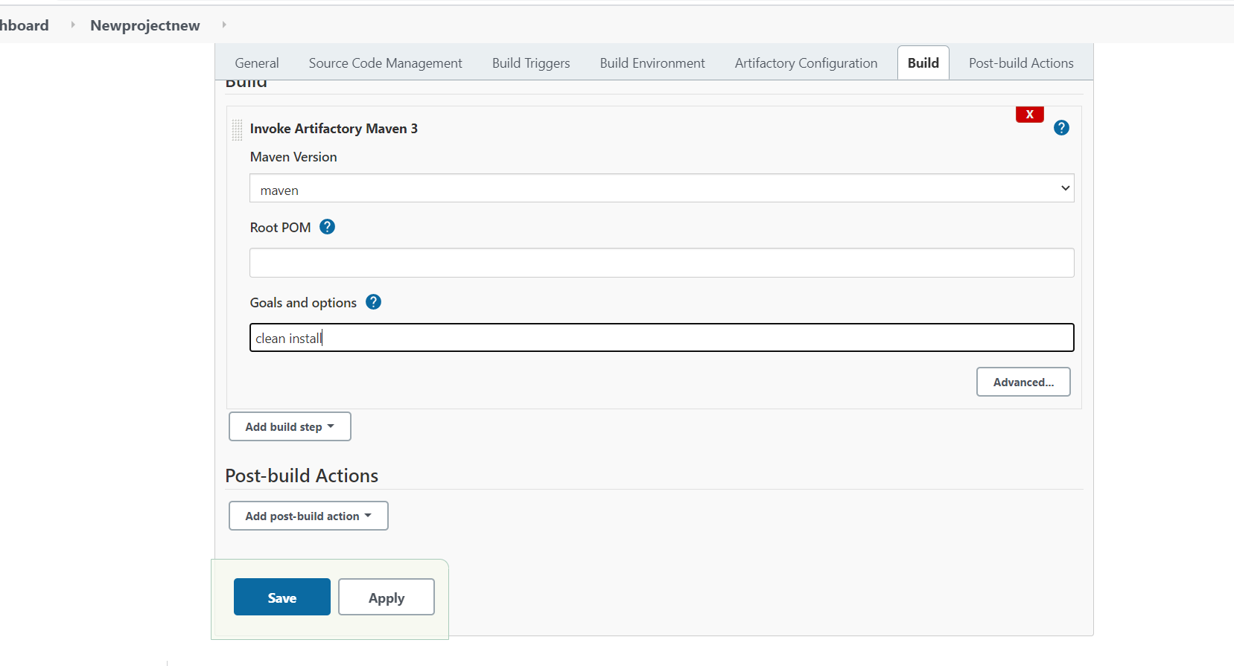

**Now build the project**

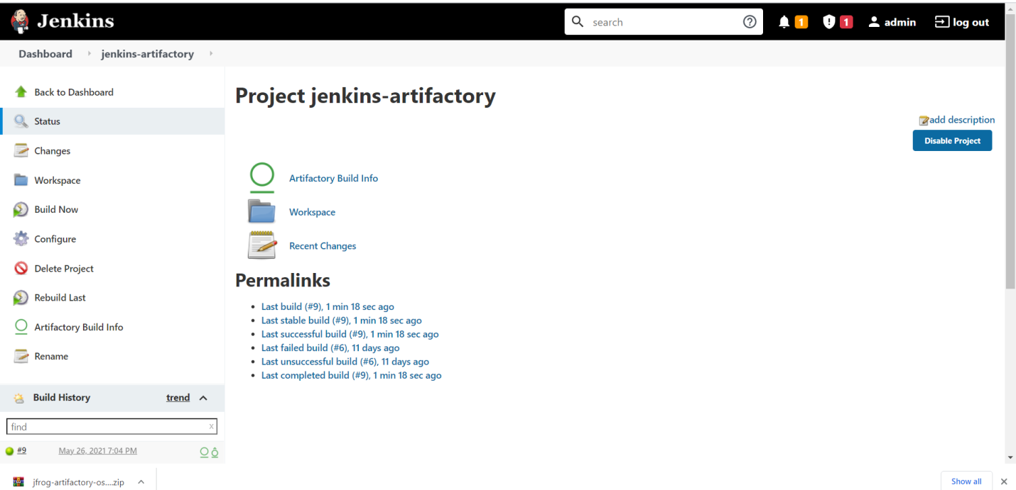

**Finally build success**

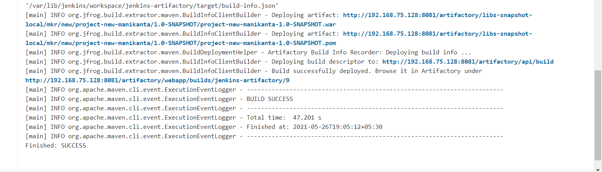

**If build success , go to artifactory account check for war/jar files**

